**Playonsports Code Test**

***To see schools results by state***

1. Click on the Search Term dropdown to select a state



1. Click in the Search By dropdown to select the state association key



1. Click Get Schools button

1. Table will populate with data for your selection

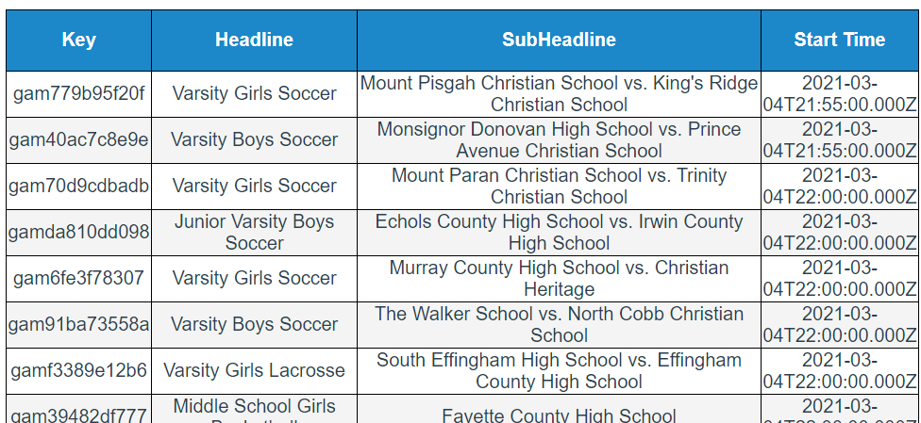

1. To change between states, repeat steps 1 & 2

***To see schools by date***

1. Click in the Start Date input field

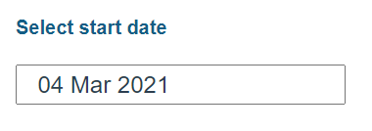

1. calendar will display, select a date

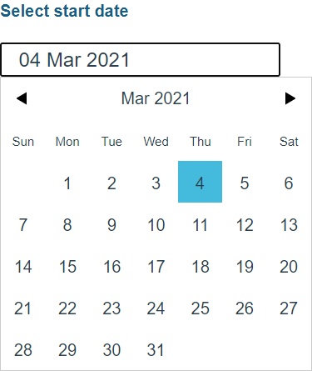

1. Click in the End Date input fiel

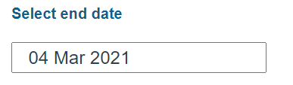

1. A calendar will display, select a date

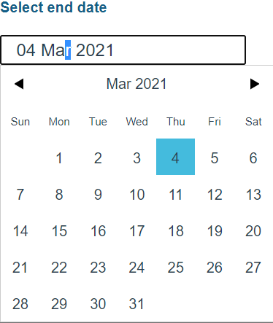

1. The table will display with data

